R User Guide

2.3.7 Health facility mapping
R User Guide

Developer: UK ONS
Version 07/08/2026 - First Submission

Unit information
Section | Content
Unit ref and name: | 2.3.7 Health Facility Mapping
Developer country | UK
Tool name | Geospatial analysis of access to healthcare facilities
Version | 06/08/2026 - Version submitted for First round review
Tool byline | A generalisable healthcare accessibility tool that combines health facility locations, WorldPop population data, and road-network routing to estimate population who are outside a specified distance of a health facility.
Tool description | Effective delivery of healthcare services requires populations to have sufficient access to healthcare facilities. Accurate mapping of a country’s national health system infrastructure can improve planning and management for healthcare provision and ensure equitable resource distribution, particularly in response to epidemics and outbreaks. Unfortunately, many low and middle income countries (LMICs) lack such resources. This work is aimed at addressing this gap by providing a generalised tool for mapping healthcare facilities and their accessibility to populations in LMICs. The tool is designed to be flexible, allowing users to configure the analysis for different countries.  This tool generates a map of healthcare facilities with metrics of accessibility for local populations in LMICs. It combines:  - Georeferenced healthcare facilities  - Small area population estimates (WorldPop)  - Road network data (OpenStreetMap via Geofabrik)  Using road network routing software, the tool generates travel-time matrices between populated grid cells and healthcare facilities, then derives network distances from the travel times and presents them in an interactive dashboard.
Secondary title (optional) | N/A
Instructions front end (optional) | Quick Guide:  - Clone the repository  - Follow the instructions in the docs/R or docs/python folder to:  - Import and prepare the data  - Create the closest facility travel time matrix  - Run the Quarto dashboard and view the results  Detailed instructions can be found in the user guides or the docs/R or docs/python folders in the repository
Instructions back end (optional) | Dashboard guide  Identify estimated populations that reside within or beyond your selected distance of a health facility. The dropdown menus allow users to select individual subnational areas or the whole of the country. Healthcare facilities can be selected by type, for example: hospital, clinic, dispensary, private and unclassified. It also possible to choose estimated populations by subgroup:  - Females  - Males  - Children (0-14)  - Working-age adults (15-64)  - Older people (65+)  - Women of reproductive age (15-49)  Finally users can toggle between estimated populations that live *within* and *outside* the chosen distance of a healthcare facility.  The map will automatically zoom to the area of interest and update summary statistics in the right panel.
Link to tool | https://github.com/datasciencecampus/geospatial-healthcare-facilities
Tags | Practitioner, Tool, Geospatial, Health facility, Mapping, Accessibility, Data Science, UK, Malawi
Image of tool | 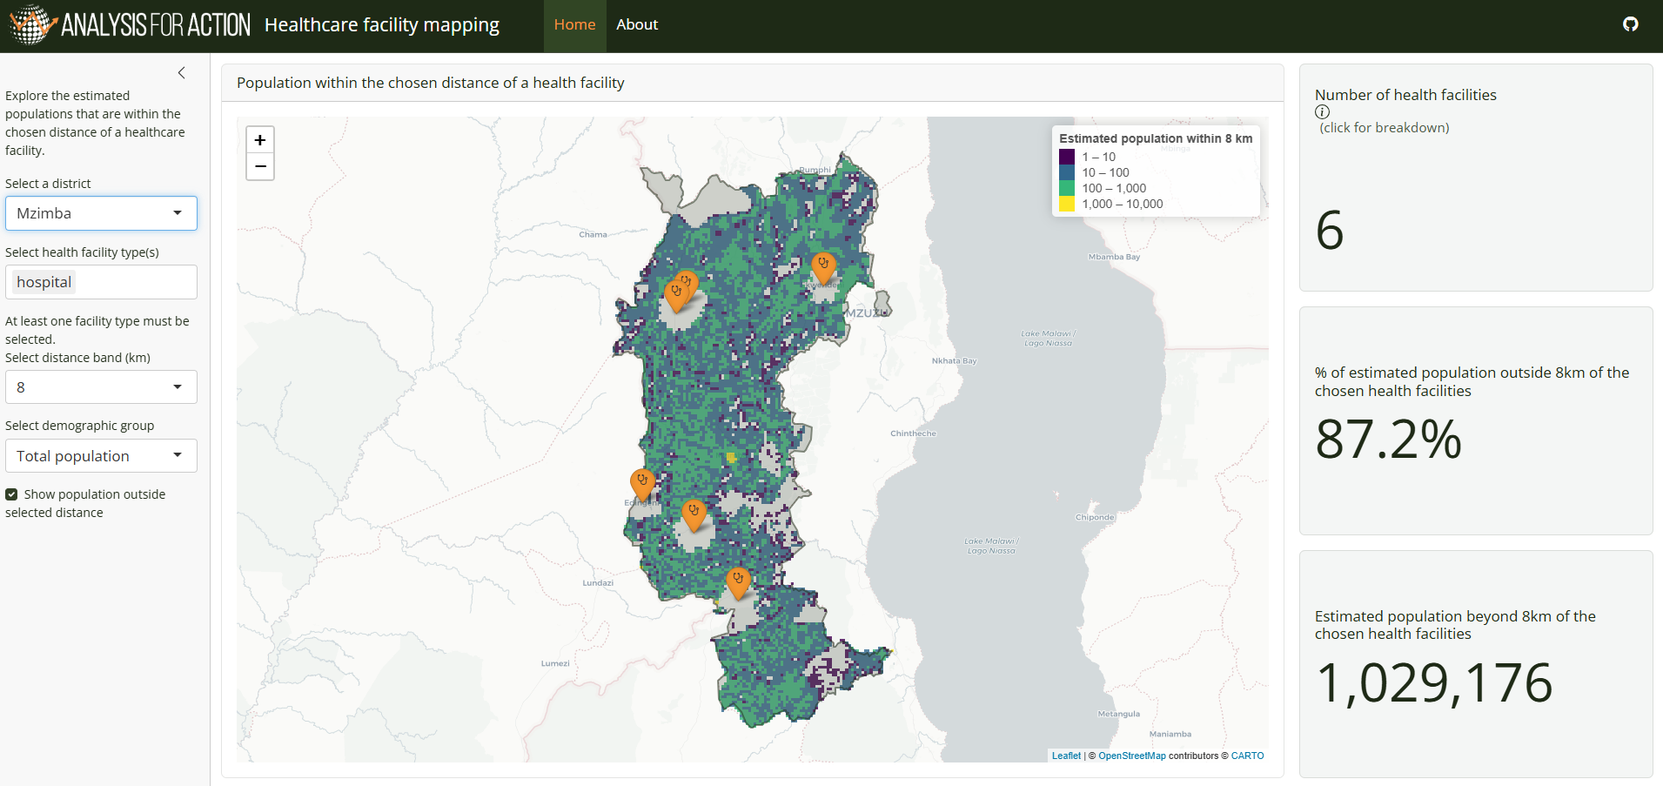

1. Introduction

1.1. What this guide is for
This guide covers how to install and run the Health Facility Mapping tool using the main R workflow.
This guide covers:
- Overview of the R workflow
- How to clone the repository
- Installation of packages
- Configuration for user specific contexts
- Running the pipeline, including:
  - Data preparation
  - Travel time analysis
  - Dashboard set up
- Troubleshooting

2. R workflow overview

2.1. What this workflow does
The R pipeline estimates travel times from populated grid cells to healthcare facilities across a road network, and presents the results in an interactive dashboard.

It combines:
- Road network data from OpenStreetMap (via Geofabrik)
- Gridded population estimates and demographic breakdowns from WorldPop
- Administrative boundaries from OpenStreetMap or a user-provided boundary file
- Health facility point data from a user-provided file or URL

2.2. Where users provide data
Users can provide input data directly through the configuration file at src/r/dashboard/config/config.yaml.
- Boundaries: set districts_filepath to a local boundary file (instead of downloading from OpenStreetMap).
- Healthcare facilities: set facility_list_filepath to a local file, or facility_list_url to a downloadable source.
- Population: optionally set population_filepath to a local WorldPop zip file (otherwise the pipeline downloads from WorldPop using configured year and release values).
These user-provided inputs are then processed by src/r/dashboard/run/01_preprocess.R before travel-time analysis.

2.3. Pipeline stages

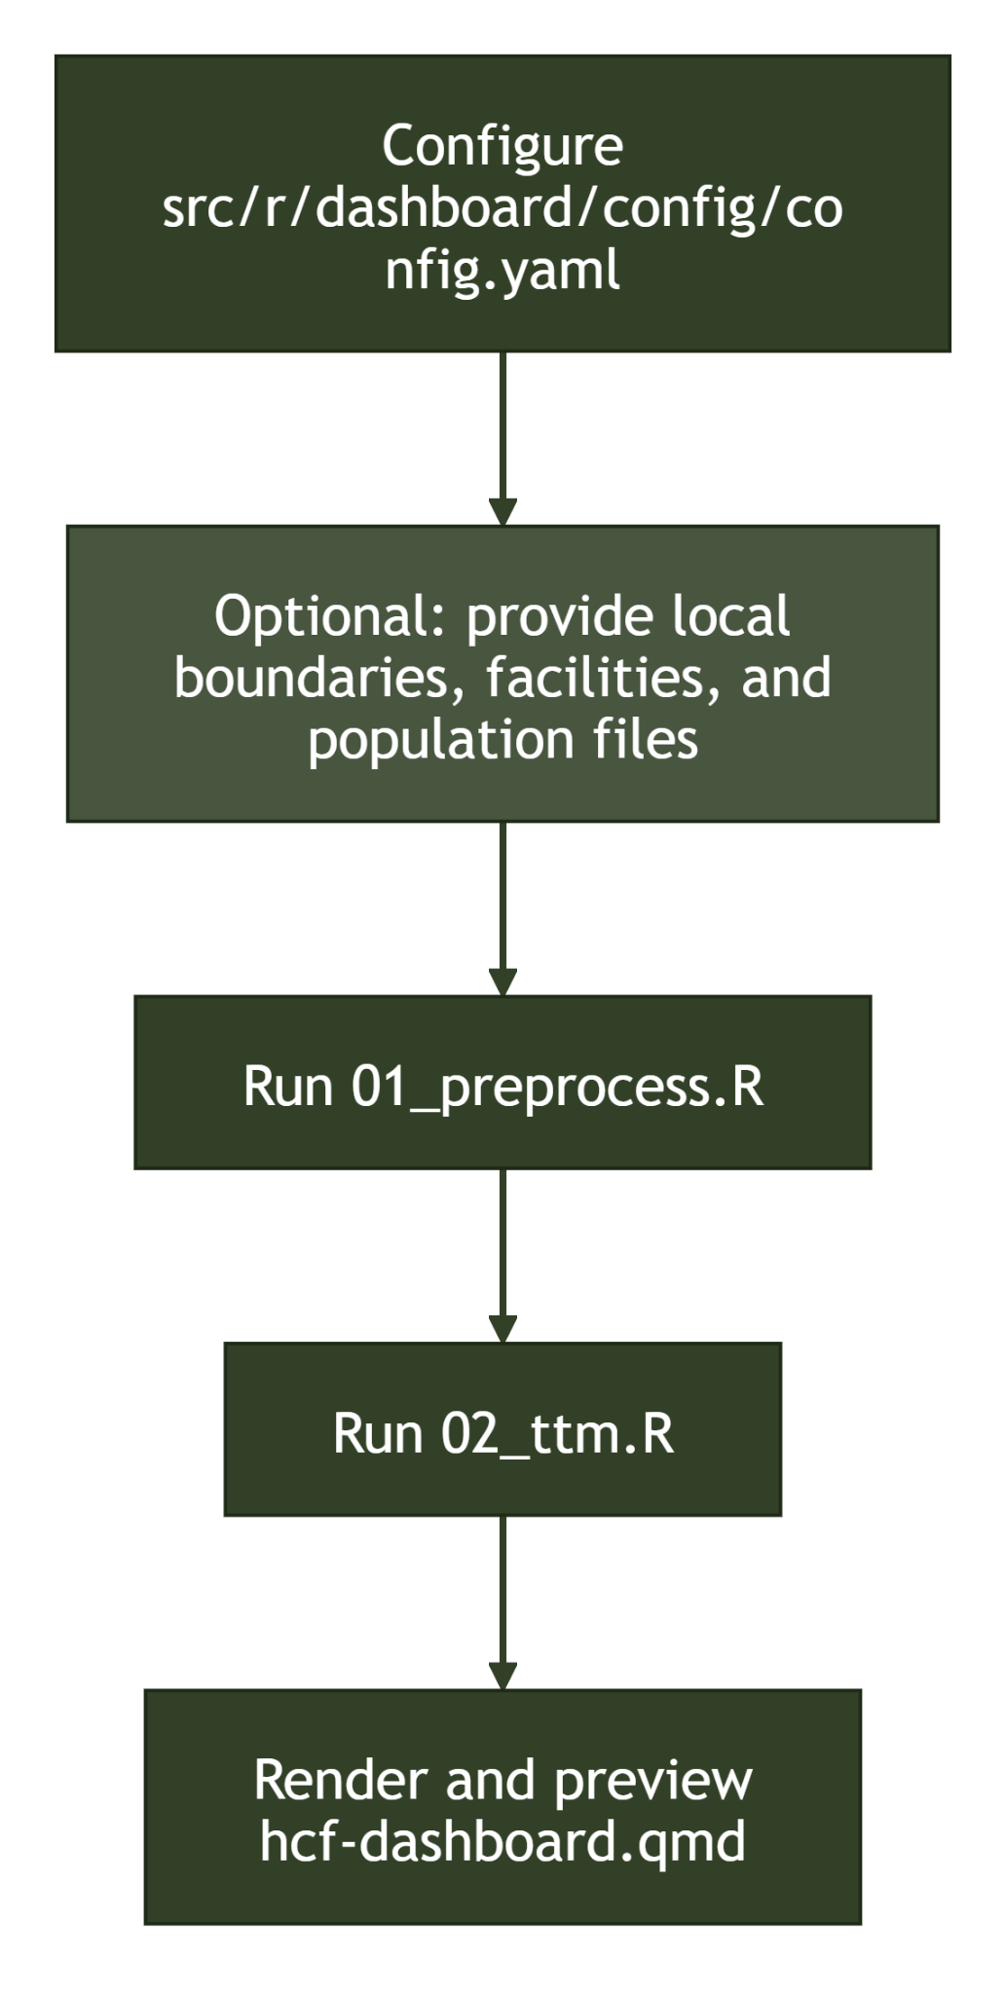

Stage | Script / file | Output
Data preparation | src/r/dashboard/run/01_preprocess.R | Country boundaries GeoJSON, healthcare facilities CSV, and WorldPop geodemographics raster
Travel time analysis | src/r/dashboard/run/02_ttm.R | Closest travel-time results in CSV and Parquet
Dashboard render and launch | src/r/dashboard/hcf-dashboard.qmd | Local interactive Quarto + Shiny dashboard

2.4. Technology stack
Component | Technology
Routing engine | r5r
Geospatial processing | sf, terra, osmdata
Population and data processing | dplyr, purrr, arrow
Dashboard framework | Quarto + Shiny for R
Mapping | Leaflet for R

3. Installation

3.1. Prerequisites
The following prerequisites are needed to run the R workflow:
- R 4.3 or later
- RStudio or VS Code with an R extension
- Java 21 for r5r
- Quarto to render and view the dashboard output

3.2. Cloning the repository
Clone the repository and move into the project folder:
terminal
git clone https://github.com/datasciencecampus/geospatial-healthcare-facilities.git
cd geospatial-healthcare-facilities

3.3. Install R packages
The R workflow includes a DESCRIPTION file at src/r/dashboard/DESCRIPTION, which can be used to install dependencies.

From an R session in the repository root:
R
install.packages("devtools")
devtools::install_deps("src/r/dashboard", dependencies = TRUE)

This installs the packages needed for the two main pipeline scripts:
- src/r/dashboard/run/01_preprocess.R
- src/r/dashboard/run/02_ttm.R

It also installs optional dashboard and test dependencies declared in Suggests.

If you need a manual fallback, install the core runtime packages with:

R
install.packages(c(
"arrow",
"countrycode",
"curl",
"dplyr",
"here",
"httr",
"jsonlite",
"osmdata",
"purrr",
"r5r",
"rJavaEnv",
"readr",
"readxl",
"rlang",
"sf",
"stringr",
"terra",
"yaml"
))

If devtools::install_deps() fails on R 4.5 with messages that specific package versions do not exist. A practical workaround is to install the required versions explicitly with pak:

R
install.packages("pak")
pak::pak("osmdata@0.3.0")
pak::pak("r5r@2.3.0")

3.4. Java set up for r5r
The travel-time stage in 02_ttm.R builds an r5r network and requires a working Java installation. The script uses rJavaEnv::java_quick_install(version = 21), but it is still better to verify that Java is available before running the pipeline.

In R install java with the following command and type "yes" when prompted for consent to install the JDK:
R
rJavaEnv::java_quick_install(version = 21)

Check that Java is installed and configured correctly with:
R
rJavaEnv::java_check_version_rjava()

If Java is already installed and configured correctly, these checks should pass without further changes.

3.5. Quarto
Quarto is required to render and inspect the dashboard output produced from the travel-time results.

Download and install Quarto from quarto.org, then verify it is on your PATH:
terminal
quarto --version

3.6. Verify the setup
After installing packages, a simple check is to load the dashboard package from its local folder and confirm dependencies load cleanly.
R
devtools::load_all(here::here("src", "r", "dashboard"), quiet = TRUE)

You can then move on to configuring:
- the country
- boundary source
- facility source
- WorldPop inputs
- district assignment method
See section 4. Configuration.

3.7. Running the full pipeline
Once installed and configured, the entire pipeline can be run end-to-end from a single entry point at the repository root:
R
source(here::here("src", "r", "dashboard", "_run_all.R"))

This runs 01_preprocess.R, 02_ttm.R, and then launches the dashboard. The numbered scripts can still be run independently if you only need to re-run a specific stage — for example, after updating config or facility data without repeating the travel-time computation.

4. Configuration
All R pipeline settings are read from src/r/dashboard/config/config.yaml.

Update this file before running:
- src/r/dashboard/run/01_preprocess.R
- src/r/dashboard/run/02_ttm.R

4.1. Required settings

Country
Set country to the full English name of your target country:
yaml
country: Malawi

This value is used to:
- resolve country codes for WorldPop and Geofabrik downloads
- name output files such as <country>_districts.geojson and <country>_closest_times.csv

Coordinate reference system
Set crs to the output CRS used for point coordinates and saved boundary layers.
yaml
crs: 4326

4326 (WGS84 lon/lat) is the default and is recommended unless you have a specific reason to export in another CRS.

4.2. Input settings

District boundaries
You can provide local boundaries or download them from OpenStreetMap.
yaml
## Boundaries
### Local filepath to the boundary file for the country
districts_filepath:
district_name_column:
### If no boundary files added boundaries are pulled from OpenStreetMap
admin_level:
admin_level_name:

How these fields behave:
- districts_filepath: if set, boundaries are read from this local file.
- district_name_column: optional when using a local file. If left blank, the first column is used for the area names.
- admin_level: used only when districts_filepath is not provided and boundaries are downloaded from OpenStreetMap. OpenStreetMap admin levels vary by country. For help selecting the correct admin level see the OpenStreetMap wiki.
- admin_level_name: display label used in the dashboard UI (for example, district).

Healthcare facilities
Provide either a local file path or a URL.

yaml
facility_list_filepath:
facility_list_url: "https://..."

Behavior:
- If facility_list_filepath is set, that file is used.
- Otherwise, if facility_list_url is set, the file is downloaded and processed.
- If both are empty, preprocessing will fail.

Note
For guidance on sourcing and downloading facility data, including expected column structure, see 5.Data preparation: Healthcare facilities.

Population input (WorldPop)
If population_filepath is blank, the pipeline will download WorldPop data using the worldpop settings.
yaml
population_filepath:
worldpop:
year: 2025
release: "R2025A"
version: "v1"

Notes:
- release and version must match an available WorldPop directory layout.
- If you already have the WorldPop zip file, set population_filepath to skip download.
Note
For guidance on downloading WorldPop data, see 5. Data preparation: Population data.

4.3. Processing settings

District assignment method
02_ttm.R assigns a district to each population grid cell before travel-time analysis.
As some grid cells may overlap multiple districts, you can choose how to resolve ambiguous assignments.

yaml
boundary_assign_method: "zonal"

Supported options:

- zonal: Recommended. Resolves ambiguous boundary cells by assigning them to the district with the largest area overlap.
- raster: Resolves ambiguous boundary cells by assigning them to the district that contains the centroid of the grid cell. This is faster than zonal but may produce less accurate results so is only recommended to be used for testing.
- any other value falls back to a direct spatial join method.

Transport mode
Default is "BICYCLE". Set this in src/r/dashboard/config/config.yaml:

yaml
travel_time:
mode: "BICYCLE"

This tool currently only supports "WALK" and "BICYCLE" modes.

max_travel_time
Sets the upper limit at which travel times are returned. Any routes beyond this threshold are excluded. Default is 167 minutes.

- Increasing this value captures more origin-destination pairs but increases runtime and output file size.
- Decreasing it risks excluding journeys that fall within accessibility thresholds of interest.

At 167 minutes, approximate maximum travel distances are:
- Bicycle: ~33 km
- Walking: ~10 km

n_threads
The number of parallel threads used by r5r for travel-time computation. Set to 4 as default. Adjust based on available CPU cores.

Java memory
The script sets Java heap memory to 2 GB before building the network:

yaml
r5r:
java_memory: 2 # Java memory allocation for r5r. Defaults to 2GB

Increase this if the network build fails with an out-of-memory error.

4.4. Example config
yaml
country: "Malawi"
crs: 4326
districts_filepath: "path/to/malawi_boundaries.geojson"
district_name_column:
admin_level:
admin_level_name:

facility_list_filepath: "path/to/malawi_facilities.geojson"
facility_list_url:
Population_filepath:
worldpop:
year: 2025
release: "R2025A"
version: "v1"
boundary_assign_method: "zonal"
travel_time:
mode: "BICYCLE"
max_travel_time_mins: 167
r5r:
n_threads: 4
java_memory: 2

5. Data Preparation
The R preprocessing stage is handled by src/r/dashboard/run/01_preprocess.R.

This script prepares the three core inputs needed by the travel-time stage:
- district boundaries
- healthcare facilities
- WorldPop population subgroup rasters

5.1. Before running
Ensure you have:
- Installed the R dependencies described in 01 — Installation.
- Updated src/r/dashboard/config/config.yaml for your country and data sources.
- Confirmed that any local boundary or facility files referenced in the config exist.

5.2. What 01_preprocess.R does
The preprocessing script runs these steps in order:
- Read src/r/dashboard/config/config.yaml.
- Load district boundaries from a local file or download them from OpenStreetMap.
- Load healthcare facilities from a local file or download them from a configured URL.
- Clean and standardise the facility data.
- Download or reuse WorldPop age-sex population inputs.
- Create subgroup rasters and a combined geodemographics.tif raster stack.

5.3. Data requirements
There are four datasets required to run the pipeline:

Name | Source | Type | Licence
Administrative boundaries | OpenStreetMap (OSM) | GeoJSON | ODbL
Healthcare facilities | Government healthcare facility registers or healthsites.io | .csv | ODbL
Population estimates | WorldPop | .tif | Creative Commons Attribution 4.0 International License
Road network | OpenStreetMap (OSM) | .pbf | ODbL

5.4. Administrative boundaries
Administrative boundaries are controlled by these config fields:
yaml
districts_filepath:
district_name_column:
admin_level:
admin_level_name:

Two input modes are supported:
- Local file: set districts_filepath to a .shp, .gpkg, .geojson, or .json file.
- OpenStreetMap: leave districts_filepath blank and provide country plus a suitable admin_level.
- If district_name_column is blank for a local file, the first column in the boundary layer is used as the administrative unit label.

The admin_level_name is used in the dashboard UI to label the administrative level (for example, district).

The script writes the processed boundaries to data/boundaries/<country>_districts.geojson

5.5. Healthcare facilities
Healthcare facilities are controlled by:
yaml
facility_list_filepath:
facility_list_url:

Two input modes are supported:
- Local file: set facility_list_filepath.
- Remote file: leave facility_list_filepath blank and set facility_list_url.

Supported formats depend on the source loader and currently include:
- CSV
- Excel (.xlsx)

Flexible source — healthsites.io via HDX
The data landscape for health facility datasets varies from country to country. In many cases, a publicly available register maintained by the relevant authorities, such as a Ministry of Health, is likely to provide the most reliable source.

A country-owned dataset should usually be the first choice where one is available and of reasonable quality. In practice, that means either:
- downloading the source file yourself and pointing facility_list_filepath at it, or
- setting facility_list_url to a direct downloadable file URL when a stable endpoint exists.

In an effort to create a generalised tool, we have identified the data from healthsites.io as a reasonable data source to experiment with initially. The advantages are that data is available for most countries around the world and is publicly downloadable from the Humanitarian Data Exchange (HDX) platform. The data can also be explored within healthsites.io to check for suitability before interacting with code.

In the current R pipeline, Healthsites data is not fetched automatically. The typical approach is to download the file manually and set facility_list_filepath in config.yaml.

Suggested steps:
- Visit the Humanitarian Data Exchange (HDX) website
- Enter <country> healthsites in the search bar
- Select the dataset called 'Global Healthsites Mapping Project'
- Navigate to the bottom of the next page and select <country>-healthsites-csv to download the data.
- Set facility_list_filepath to the downloaded file.

Healthsites-style CSV inputs are supported by the current R cleaning code when fields such as x, y, and osm_id are present.

Bespoke health facility datasets
If using a country-specific dataset, it will need to be processed into the format the R pipeline expects.

Required columns (facilities without usable coordinates are silently dropped):
- lon and lat, or longitude and latitude columns — usable point coordinates for each facility.

Recommended columns (not required, but enable richer outputs and dashboard filtering):
- id — stable unique identifier for each facility. If absent, a sequential integer is generated automatically, but this will not be consistent across runs.
- name — e.g. "North-East Hospital"
- type — e.g. "Hospital", "Clinic", "Pharmacy"
- ownership — e.g. "Government", "Private"

These can provide useful additional context, but they are not essential for the pipeline to function.

The pipeline expects the following columns. Only lon/lat are required; all others are optional but recommended:
Column | Description | Data type | Example | Required
id | Unique id | String | LL040529 | No
lon | Longitude | Double | 33.78512 | Yes
lat | Latitude | Double | -13.97639 | Yes
name | Name of healthcare facility | String | Kamuzu Central hospital | No
type | Type of healthcare facility | String | Hospital | No
ownership | Ownership of healthcare facility | String | Government | No

The script writes the processed facilities to data/poi/<country>_healthcare_facilities.csv

Note - Data quality
There is no standardised approach to quality assure the health facility data within the codebase. The responsibility rests with the user to suitably quality assure any health facility data used for this analysis, preferably using local knowledge, and to understand its limitations, biases and implications. Known issues to look out for:
- Missing records
- Incorrectly located facilities
- Duplicate entries
- Implausible counts or distributions by type

5.6. Population data
Population inputs are controlled by:
yaml
population_filepath:
worldpop:
year: 2025
release: "R2025A"
version: "v1"

Two modes are supported:
- Automatic download: leave population_filepath blank and the script will download the WorldPop zip file for the configured country, year, release, and version.
- Local zip file: set population_filepath to an existing WorldPop zip file.

Population estimates for different demographic groups can be downloaded from WorldPop. Enter the country of interest in the search bar and select a year.

Click the corresponding 'Data & Resources' and download the .zip file from the green button on the subsequent page. The .zip file will contain population estimates for different demographic groups at 100m2 resolution in .tif format. Please provide a link to the .zip file in the config.yaml file.

The preprocessing step then:
- extracts the WorldPop files into data/raw/
- creates subgroup rasters in data/population/<iso3>_agesex_<year>/
- creates a combined geodemographics.tif stack used later by 02_ttm.R

Generated rasters include:
- females.tif
- males.tif
- children_(0-14).tif
- working-age_adults_(15-64).tif
- older_people_(65+).tif
- women_of_reproductive_age_(15-49).tif
- total_population.tif
- geodemographics.tif

5.7. Road network
Road network data is provided by OpenStreetMap. The data is downloaded programmatically in the pipeline so there is no requirement to download the data manually.

5.8. Run the script
From the repository root, first load the local dashboard package in your R session:
R
devtools::load_all(here::here("src", "r", "dashboard"), quiet = TRUE)

Then run the preprocessing script:
R
source(here::here("src", "r", "dashboard", "run", "01_preprocess.R"))

If you prefer to run it non-interactively from the command line, use:
terminal
Rscript src/r/dashboard/run/01_preprocess.R

To run the full pipeline end-to-end (preprocessing, travel-time, and dashboard), use _run_all.R from the repository root instead:

R
source(here::here("src", "r", "dashboard", "_run_all.R"))

5.9. Validate outputs
After the script completes, confirm these files exist:
- data/boundaries/<country>_districts.geojson
- data/poi/<country>_healthcare_facilities.csv
- data/population/<iso3>_agesex_<year>/geodemographics.tif

You should also expect to see extracted WorldPop source files under data/raw/.

5.10. Common issues
- If boundary download fails, provide a local boundary file via districts_filepath.
- If facility download fails, download the file manually and point facility_list_filepath at it.
- If WorldPop download fails, provide the local zip file path via population_filepath.
- If the wrong district names are used from a local boundary file, set district_name_column explicitly.

The next section covers how to build the transport network using 02_ttm.R.

6. Travel Time Analysis
Travel time estimation is carried out by src/r/dashboard/run/02_ttm.R. For each facility type, it computes the travel time from every populated grid cell to the closest facility along the road network.

6.1. Before running
Ensure you have completed the data preparation step and the following output files exist:
- data/boundaries/<country>_districts.geojson
- data/poi/<country>_healthcare_facilities.csv
- data/population/<iso3>_agesex_<year>/geodemographics.tif

For more information, see the previous section.

6.2. What 02_ttm.R does
The script runs these steps in order:
- Load districts and healthcare facilities produced by 01_preprocess.R.
- Convert the population raster to points.
- Assign each population point to a district using the method set in config.
- Download the country OSM PBF file from Geofabrik (skipped if already present).
- Build the r5r transport network from the OSM data.
- For each facility type, compute the travel-time matrix and find the closest facility per population point.
- Write the results as CSV and Parquet.

6.3. Run the script
From an R session in the repository root, first load the local dashboard package:
R
devtools::load_all(here::here("src", "r", "dashboard"), quiet = TRUE)

Then run the travel-time script:
R
source(here::here("src", "r", "dashboard", "run", "02_ttm.R"))

Or non-interactively from the command line:
terminal
Rscript src/r/dashboard/run/02_ttm.R

To run the full pipeline end-to-end (preprocessing, travel-time, and dashboard), use _run_all.R from the repository root instead:
R
source(here::here("src", "r", "dashboard", "_run_all.R"))

6.3. Outputs
Results are written to data/ttm/:
- data/ttm/<country>_closest_times.csv
- data/ttm/<country>_closest_times.parquet

Each row represents a population point with its closest facility, travel time, and facility type. The Parquet file is used directly by the dashboard.

Output columns include:

Column | Description
id | Population point identifier
lon, lat | Coordinates of the population point
district | Assigned district name
population | Population count at the grid cell
facility_type | Type of the closest facility
from_id | ID of the closest facility
travel_time_p50 | Median travel time in minutes to the closest facility

6.4. Network build
The OSM road network is downloaded automatically from Geofabrik and saved to data/network/<country>/. Subsequent runs reuse the existing file unless overwrite = TRUE is set in the download_geofabrik_pbf() call.

The r5r network is built from the PBF file each run. This step can take several minutes depending on country size.

6.5. Common issues
- If the r5r network build fails with a Java memory error, increase java.parameters before running.
- If no travel times are returned for a facility type, check that facilities of that type have coordinates within the network extent.
- If the Geofabrik download fails, download the PBF manually from download.geofabrik.de and place it in data/network/<country>/.

7. Dashboard
The dashboard visualises healthcare accessibility metrics interactively. It is built using a Quarto .qmd file backed by Shiny for R, and is served locally via quarto preview or shiny::runApp().

7.1. Prerequisites
The necessary software and packages must be installed. Please refer to 3. Installation for more information.

Required data outputs
The dashboard reads pre-computed travel-time data and geospatial inputs. Before rendering, you must have completed the full analysis pipeline so that the following files exist for your configured country (e.g. Malawi):
- data/ttm/<country>_closest_times.parquet
- data/boundaries/<country>_districts.geojson
- data/poi/<country>_healthcare_facilities.csv
- data/population/<iso3>_agesex_<year>/geodemographics.tif

Refer to 5. Data preparation and 6. Travel time analysis for instructions on generating these files.

Configuration
Open src/r/dashboard/config/config.yaml and confirm the country field matches the context you want to visualise:
yaml
country: Malawi

All file paths in the dashboard are derived from this value. No changes to the .qmd file itself are required.

7.2. Running the full pipeline with _run_all.R
If you have not yet run the preprocessing and travel-time stages, the simplest approach is to run the full pipeline end-to-end from the repository root:
R
source(here::here("src", "r", "dashboard", "_run_all.R"))

This runs 01_preprocess.R, 02_ttm.R, and then launches the dashboard automatically. If the pipeline has already been run and you only want to launch the dashboard, follow the steps below.

7.3. Render and preview the dashboard
From a terminal in the repository root, run the following Quarto command to render and preview the dashboard:
terminal
quarto preview src/r/dashboard/hcf-dashboard.qmd

This will:
- Render the Quarto dashboard file
- Start a local Shiny server
- Open the dashboard in your default browser

The dashboard is now running interactively and will hot-reload if you make changes to the .qmd file.

7.4. Interacting with the dashboard
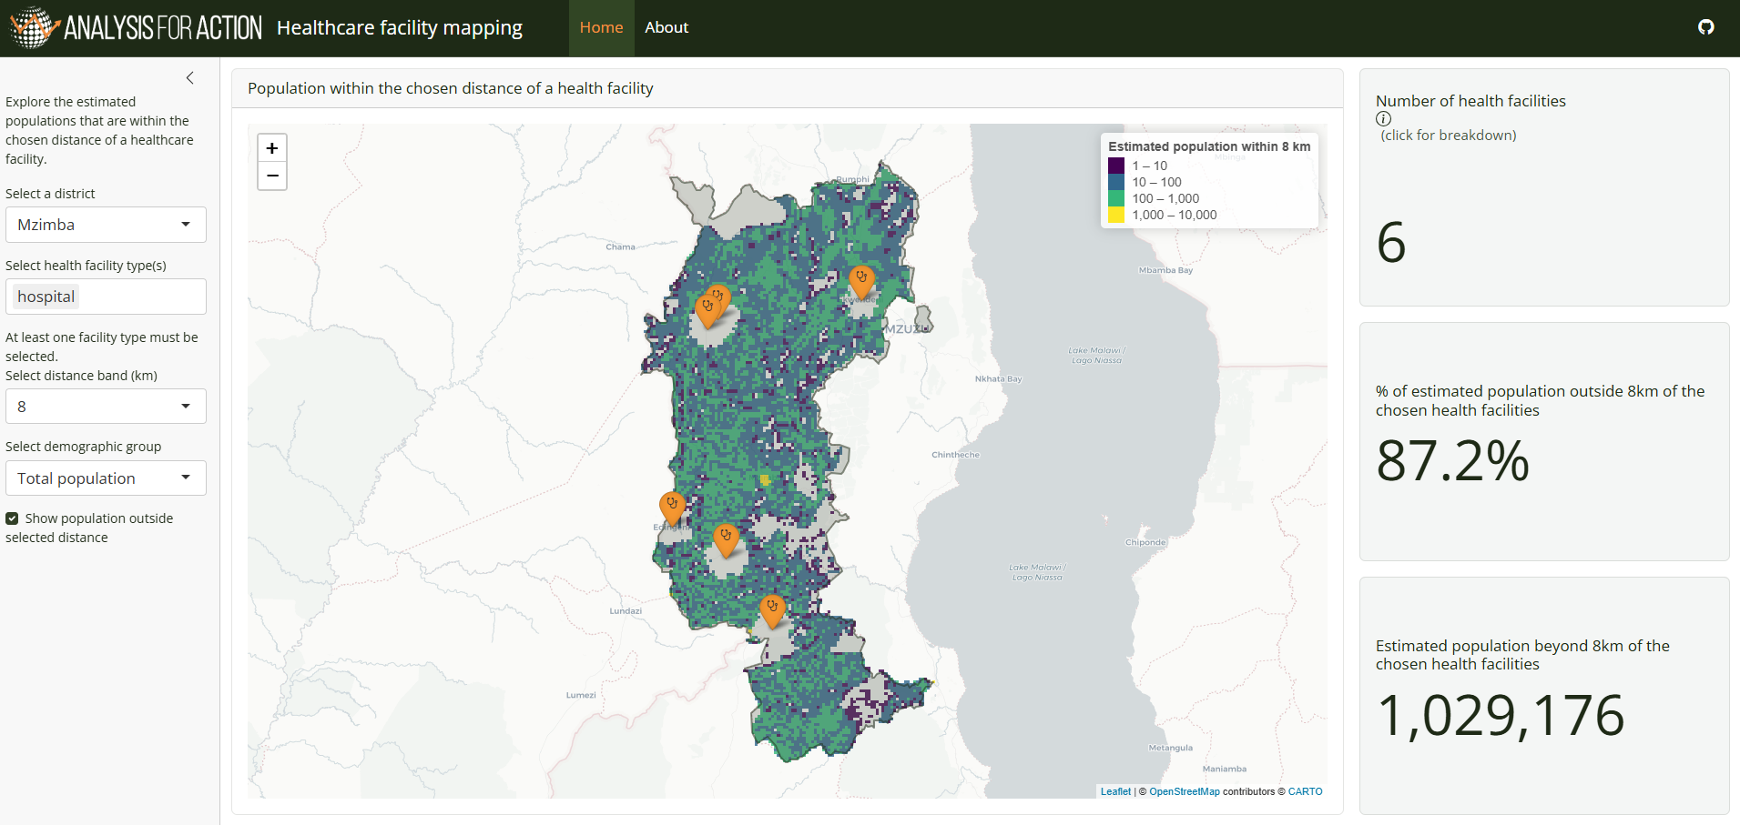
Once open in a browser, the dashboard provides controls to filter and explore healthcare accessibility metrics:
Control | Description
District selector | Filter to a specific district or view the country level
Facility type filter | Select one or more healthcare facility types to restrict the map and summary statistics
Distance band (km) | Set the distance threshold (5, 8, or 10 km) used to classify population as "within reach"
Demographic selector | View accessibility metrics for the total population or specific demographic groups (male, female, age bands, reproductive age)
Show outside toggle | Include or exclude population beyond the selected distance
Map | Interactive Leaflet map that updates in response to filters, showing facility locations and population grid cells

7.5. Re-rendering after changes
If you modify hcf-dashboard.qmd or any helper function in src/r/dashboard/R/, simply save the file. When using quarto preview, changes are automatically hot-reloaded.

If changes are not reflected, try stopping the preview (Ctrl+C in terminal) and re-running quarto preview.

8. Troubleshooting

8.1. Environment and installation
Problem | Likely cause | Fix
Error: object 'xxx' not found when sourcing a script | Missing R package | Run devtools::install_deps("src/r/dashboard", dependencies = TRUE) and ensure all packages installed successfully
install_deps() or package install says osmdata/r5r version does not exist (often on R 4.5) | Mirror metadata issue | Install with pak using explicit versions: install.packages("pak"), pak::pak("osmdata@0.3.0"), pak::pak("r5r@2.3.0"); then retry the pipeline
quarto: command not found | Quarto not on PATH | Install Quarto from quarto.org and restart your terminal
Java-related error when loading r5r | rJavaEnv or Java not properly configured | Run rJavaEnv::java_quick_install(version = 21) and rJavaEnv::java_check_version_rjava()

8.2. Data preparation (01_preprocess.R)
Problem | Likely cause | Fix
Error: could not find function "get_districts" | R helper functions not sourced | Ensure you are running the full script 01_preprocess.R from the repository root, which sources all required functions
Repeated Waiting 60s for retry backoff messages | Network issue or API rate limit | Check your internet connection. If using a VPN, try disabling it. If the issue persists, wait and try again later or consider downloading the file manually and set facility_list_filepath to the local file
OpenStreetMap boundary download fails | Overpass API timeout or unavailable | Set filepath in config to a local boundary file, or try again later. Increase timeout with timeout_seconds parameter in get_osm_districts
WorldPop download fails | Network issue or release no longer available | Manually download from WorldPop Hub and set population_filepath in config to the local zip file
FileNotFoundError for facility file | File not found at the specified path | Verify facility_list_filepath is correct and points to an existing file, or check the URL in facility_list_url is accessible
Healthcare facilities CSV/Excel download fails | URL no longer valid or network issue | Download the file manually and set facility_list_filepath to the local file
Warning: Removed X rows with missing longitude or latitude | Some facilities have missing coordinates | Rows without coordinates are automatically dropped. Check data quality if the number is unexpectedly high

8.3. Travel time analysis (02_ttm.R)
Problem | Likely cause | Fix
Error: java.lang.OutOfMemoryError during network build | Insufficient Java heap memory | Increase Java memory: change java.parameters = "-Xmx2G" to a larger value like "-Xmx4G" or "-Xmx8G" depending on available RAM
Error: Could not find OSM PBF file | Geofabrik download failed or file missing | Check data/network/<country>/ exists and contains a .pbf file. Re-run the download or manually place the PBF file there
Internet connection not working properly. (or automatic R5 jar download fails during r5r::build_network) | Network restrictions/firewall block automatic jar download from GitHub | Manually download r5-v7.4-all.jar from Conveyal release v7.4, then place it in your local r5r cache directory (run r5r::r5r_cache(list_files = TRUE) to print the cache location). Re-run 02_ttm.R after placing the jar
Travel time matrix is empty for a facility type | Facilities of that type outside network extent or invalid coordinates | Verify facility coordinates are valid and within the country boundary. Check that facility type values are not empty or whitespace-only
Script takes very long to complete | Large country or high max_walk_time threshold | This is expected for large countries. Consider reducing max_walk_time, increasing n_threads, or segmenting by district
Error: object 'facility_type' not found | Column name mismatch in facility data | Ensure the preprocessing step correctly named the facility type column. Verify data/poi/<country>_healthcare_facilities.csv has the expected columns

8.4. Dashboard
Problem | Likely cause | Fix
Error: cannot open file 'data/ttm/<country>_closest_times.parquet' | TTM file missing or wrong country name | Complete the full pipeline first; verify country in src/r/dashboard/config/config.yaml matches output file names exactly
Error: subscript out of bounds on dashboard load | Empty or mismatched data | Check that 01_preprocess.R and 02_ttm.R both completed successfully and produced non-empty outputs
Dashboard loads but map is blank | No facilities match the current filters | Try changing facility type or district filters. Verify facilities were written to data/poi/<country>_healthcare_facilities.csv
Error: invalid subscript on district selector | Config country name invalid or data files missing | Verify the country in config is spelled correctly (e.g. "Malawi", not "malawi")
Shiny error: object 'config' not found | Dashboard .qmd setup chunk failed | Check that src/r/dashboard/config/config.yaml exists and is valid YAML. Try restarting the Shiny preview
Port already in use when previewing | Another R session on the same port | Stop other R/Shiny processes, or restart RStudio and try again
Dashboard shows old data after re-running pipeline | Cached data in R session | Stop Shiny (Ctrl+C), close R, and start fresh

8.5. Common data issues

Problem | Likely cause | Fix
Facility coordinates look wrong on map | CRS mismatch or incorrect parsing | Verify facility data has valid longitude/latitude columns. Check that coordinates are in WGS84 (lon/lat) before preprocessing
Districts named incorrectly | Wrong column used as district label | Set district_name_column in config to the correct column name from your boundary file
Inconsistent facility IDs across runs | No stable id column in original data | Provide a stable id column in facility input data. Auto-generated IDs are not persistent between runs

